

**WORKSHEET**

NAME:                                                      SUBMISSIONDATE: SUBJECT:                                                PARENT SIGNATURE:

GRADE:    VI

**Early Human I &II**

1. Look at the person in the given picture and identify the profession.

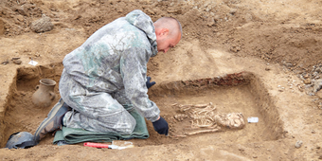

  a.Scientist           b. Archaeologist           c. Merchant       d. Traveller

2.Buildings of historical importance are called__________

  a. Manuscripts  b. Literary source      c. Monuments     d. Artifacts

3. refer to the given diagram and select the option that correctly identifies X.

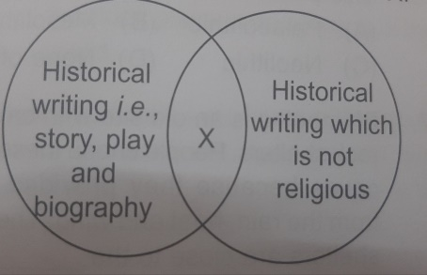

  a.Scientific literature b. Artifacts c. Secular Literature d. Continuous story

4.The text shown in the given picture is _________

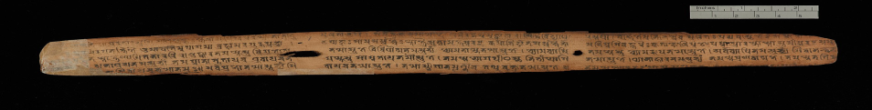

   a .A palm leaf manuscript    b. Artifact

c. An old stone inscription d.A birch bark manuscripts

5. Complete the given analogy

   Magadha: the first kingdom::_________________:development of agriculture

   a.Ganga valley  b. Indus  c. Narmada valley  d. Garo hills

6. The painting below is a cave painting found in ____________.

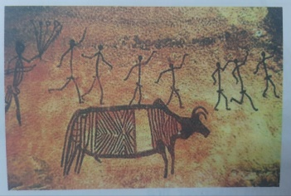

   a.Iran      b.German           c. Bhimbetka  d.Pakistan

7. **SUGIHN** unscramble the given letters to obtain the name of an early site,

    then correctly identifies the site.

    a.Neolithic    b. Palaeolithic              c. Megalithic          d. Early village

**8.** Assertion and Reasoning (Tick the correct option):

**Assertion (A):** The Mesolithic people were nomadic.  
 **Reason (R):** They began settling near rivers and lakes.

a) Both A and R are true, and R is the correct explanation of A  
 b) Both A and R are true, but R is not the correct explanation of A  
 c) A is true, but R is false  
 d) A is false, but R is true

9. Look at the map. Write the Stone Age period each site belongs to. Write P for Palaeolithic, M for Megalithic and N for Neolithic sites with their state’s name.

            Sites Name   Stone age State

1. Burzahom          ______ _________
2. Bhimbetka       ______ _________
3. Chirand               ______ _________
4. Brahmagiri         ______ _________

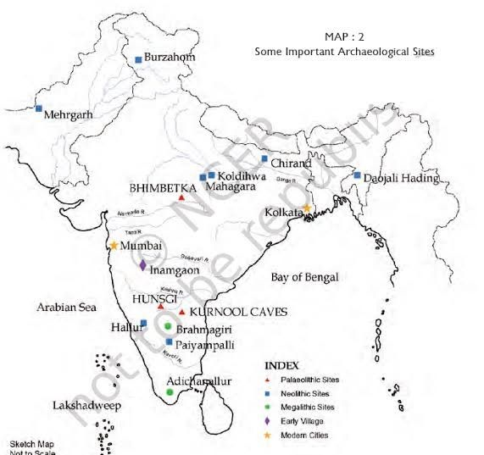

10. How was the invention of wheel an important step towards progress for  early humans?

**Match the Following:**

|  |  |
| --- | --- |
| **A** | **B** |
| 1. Palaeolithic  Age | a. Wheel invented |
| 2. Mesolithic Age | b. Beginning of  agriculture |
| 3. Neolithic Age | c. Rough stone tools |
| 4. Chalcolithic Age | d. Microliths |